

**Independent University, Bangladesh**

Search Engine Optimization and Digital Marketing Strategies on

Google Ads at

**MediaE360**

An undergraduate internship report submitted by

**Anupom Hossain Meraj (Student ID: 1530851)**

Under the guidance of

**Mrs. Sabrina Alam**

Lecturer

Department of Computer Science and Engineering

Independent University, Bangladesh

In consideration of the partial fulfilment of the requirement for the

degree of BACHELOR OF SCIENCE in Computer Science Department of Computer Science and Engineering SPRING 2021

**Submission Date**: 23rd May, 2021

## Attestation

I understand the nature of plagiarism, and I am aware of the University’s policy on this. I certify that this is an original work by me during my internship period. However, following internationally accepted academic guideline of using others written work and / or software (in the form of code) in my University project is properly cited if used in any part of this work.

Signature: Signature:

Name: --------- Name: -----------

## Acknowledgement

First of all, I would like to thank almighty Allah, for his grace in accomplishing my internship report timely.

I would like to express my gratitude to the **Faculty of Computer Science and Engineering** department to keep internship credit in the curriculum of the graduation program and give me a scope of tasting the flavor of industry-oriented tasks and the field of work with my interest. I would like to thank specially and heartily to my supervisor, **Mrs**. **Sabrina Alam**, Lecturer, Department of Computer Science and Engineering, Independent University, Bangladesh, who encouraged and directed me with her continuous guidance, invaluable instructions, stimulating suggestions and thoughtful advice during pursuing this internship and preparation of this report.

I am also thankful to my organization supervisor **Shameem Ahmed**, CEO & Founder, **MediaE360** from the core of my heart for her kind support, guidance, constructive, supervision,instructions and advice as well as for motivating me to do the internship smoothly at **MediaE360.**

I feel proud and gratified that I was always held the under supervision of the Google Ads team and also SEO team and always got advices directly from the owner of the company, **Shameem Ahmed**. Here, with daily reporting along with mental and professional support enhances my experience in the internship life.

I am also indebted to the employees of Software development team and also specially **the CEO** who gave me immense support whileworking at MediaE360. Moreover, to prepare this report and other documentation regarding Internship Report and else I would show appreciation to all the members of **MediaE360** team, who always advised me and helped me through hands and pens. Moreover, I must mention the wonderful working environment and group commitment of this organization that has enabled me to deal with a lot of things.

## Letter of Transmittal

23rd May, 2021

Mrs. Sabrina Alam

Lecturer,

Department of Computer Science & Engineering,

School of Engineering & Computer Science,

Independent University, Bangladesh

**Subject**: Submission of Internship Report for the completion of Graduation.

Dear Madam,

I am hereby submitting my Internship Report, which is a part of the BSc. Program in Computer Science and Engineering curriculum. It is a great achievement to work under your active supervision. This report is based on, “Internship at MediaE360” I have got the opportunity to work at MediaE360 for three months, under the supervision of Shameem Ahmed, CEO & Co-founder, MediaE360.

This internship has given me both academic and practical exposures. The internship has given me the opportunity to develop a network with the corporate environment. I tried to make this report as much informative as possible with the experience I have gained during my internship period. In order to prepare a well-organized internship report, I have followed the guidelines and described the required fields with sufficient details. I, however sincerely believe that this report will serve the purpose of my internship program.

I shall be highly obliged if you are kind enough to receive this report and provide your valuable feedback. It would be my immense pleasure if you find this report useful and informative to have an apparent perspective on the issue.

Sincerely Yours,

Anupom Hossain Meraj

ID#1530851

Department of Computer Science,

School of Engineering & Computer Science,

Independent University, Bangladesh

## Evaluation Committee

. . . . . . . . . . . . . . . . . . . . . . . . . . . . . . . . . . . . . . . . . . . . . . . . . . . . . . . . . . . . . . . . . . . . . . Signature

. . . . . . . . . . . . . . . . . . . . . . . . . . . . . . . . . . . . . . . . . . . . . . . . . . . . . . . . . . . . . . . . . . . . . . Name

. . . . . . . . . . . . . . . . . . . . . . . . . . . . . . . . . . . . . . . . . . . . . . . . . . . . . . . . . . . . . . . . . . . . . . Supervisor

. . . . . . . . . . . . . . . . . . . . . . . . . . . . . . . . . . . . . . . . . . . . . . . . . . . . . . . . . . . . . . . . . . . . . . Signature

. . . . . . . . . . . . . . . . . . . . . . . . . . . . . . . . . . . . . . . . . . . . . . . . . . . . . . . . . . . . . . . . . . . . . . Name

. . . . . . . . . . . . . . . . . . . . . . . . . . . . . . . . . . . . . . . . . . . . . . . . . . . . . . . . . . . . . . . . . . . . . . Internal Examiner

. . . . . . . . . . . . . . . . . . . . . . . . . . . . . . . . . . . . . . . . . . . . . . . . . . . . . . . . . . . . . . . . . . . . . . Signature

. . . . . . . . . . . . . . . . . . . . . . . . . . . . . . . . . . . . . . . . . . . . . . . . . . . . . . . . . . . . . . . . . . . . . . Name

. . . . . . . . . . . . . . . . . . . . . . . . . . . . . . . . . . . . . . . . . . . . . . . . . . . . . . . . . . . . . . . . . . . . . . External Examiner

. . . . . . . . . . . . . . . . . . . . . . . . . . . . . . . . . . . . . . . . . . . . . . . . . . . . . . . . . . . . . . . . . . . . . . Signature

. . . . . . . . . . . . . . . . . . . . . . . . . . . . . . . . . . . . . . . . . . . . . . . . . . . . . . . . . . . . . . . . . . . . . . Name

. . . . . . . . . . . . . . . . . . . . . . . . . . . . . . . . . . . . . . . . . . . . . . . . . . . . . . . . . . . . . . . . . . . . . . Convener

## Abstract

This report highlights about the keyword research for digital marketing on Google Ads platform and the search engine optimization (SEO) department of MediaE360 and my contribution to their research. The report is broadly categorized into nine different chapters. It starts with an introduction, objectives of the study, scope of the report, Background of the project and limitation. Chapter two describes the overview of MediaE360, Chapter three focuses on Literature Review. Chapter four mainly focuses on methodology for the keyword research, SEO, Google Ads platform, implementation of keyword search tools, use of google ads, and maintenance. Chapter nine narrates a concluding summary, recommendation. This internship gave me a chance to work with real life search engine optimization and its implementation for a better return. This report mainly has been documented based on my overall work in the company as an intern.

Contents

Attestation 2

Acknowledgement 3

Letter of Transmittal 4

Evaluation Committee 5

Abstract 6

List of Figures 10

Chapter 1 12

Introduction 12

1.0 INTRODUCTION 13

1.1 Company Profile of MediaE360 14

1.2 Vision, Mission and Objective 14

Vision 14

Mission 14

Objective 15

1.2.1 Services provided by MediaE360 15

Social Media Marketing 16

Web Design & Development 16

Digital Marketing 16

Data Entry 16

The Next Generation of the Marketing 17

Key Projects of MediaE360 17

Chapter 2 21

Literature Review 21

2.0 Literature Review 22

2.1 Undergraduate Courses related to the Project 22

2.2 Internship Experience & Observation Details 22

Job Responsibilities 24

Chapter 3 25

Methodology 25

3.0 Methodology: 26

3.1 SYSTEM DEVELOPMENT METHODOLOGY (SDLC) 26

3.2 Problem Description 26

3.3 FEASIBILITY ANALYSIS 27

Technical Feasibility 27

3.3.1 Economic Feasibility 28

3.3.2 Operational Feasibility 28

3.3 SYSTEM REQUIREMENTS ANALYSIS 28

3.3.1 Platform specification 29

3.3.2 Functional requirements 29

3.3.3 Business end requirements 30

3.3.4 Non-functional requirements 30

3.3.4.1 Using SpyFU 31

Chapter 4 35

Result and Test Analysis 35

4.1 Testing 36

4.1.1 Functional Testing 36

4.1.2 System Testing 36

4.2 Test Data 37

4.2.1 Test Results 37

Chapter 5 39

Internship Outcome & Issue Analysis 39

5.2 Issue Analysis 40

5.2.1 Problems & challenges faced in the workplace 40

5.2.2 Recommendation 41

Chapter 6 43

Conclusion & Implication 43

Conclusion and implication 44

7.0 Reference 45

8.0 Appendix 46

# List of Figures

**Fig 1: Monthly volume and estimated click analysis of the keyword “dentist” on SpyFu**

**Fig 2: Monthly cost, cost per click (CPC) and search volume results by Google**

**Fig 3: Top Google Ads impressions/month data for different competitor’s analysis.**

**Fig 4: Successful related advertisers, their monthly budget and coverage percentage.**

**Fig 5: Analysis of the top ranked websites, their estimated monthly clicks and domain strength**

**Fig 6: Currently shown ads related to the same keyword on search result pages.**

**Fig 7: Repeating the same analysis for a different keyword, “dental”.**

**Fig 8: Another overview of the keyword “dentist near me” with the same analysis**

**Fig 9: Keyword research along with volume, CPC, traffic rates, etc. for NH Park Dental.**

**Fig 10: Total backlinks, URL rating, Domain rating and referring page titles for our client, NH PARK DENTAL**

# Chapter 1

# Introduction

## 1.0 INTRODUCTION

Internships are often very closely related to a student’s academic and career goals. The purpose of internship program is to help students focus on their career interests and potentials. The whole program entitles to give the opportunity to learn, observe and determine their goals and aims. Internship provides a student an opportunity to relate their theoretical knowledge with the tough real-world environments. An internship report also provides the faculty with in-depth information about the profession they are responsible for preparing students to participate in. Being an intern, the main challenge was to translate the theoretical concepts into real life experience. I started my Internship with Google Ads Team at MediaE360 on 1st March, 2021. The expectations were high and now almost nearing the end of my internship, I must admit that it was really a wonderful experience. The journey was not that simple. There were many obstacles, new systems that I had to handle with. However, after overcoming each challenge, I had discovered a new potential within myself. The skills that I have gathered are priceless to me. In addition to that, some of the non-technical skills that I have procured, combined with those technical skills will certainly prove worth in my career.

This chapter gives an outlook about the general keyword researching tasks during my internship along with the Google Ads and SEO team under the supervision of Shameem Ahmed Sir, CEO & Founder, MediaE360. Digital Marketing is a huge sector to make a good profit from but you need the proper keywords for the benefits from digital marketing. This can be done using many different type of methods, keyword research is an essential thing for digital marketing which can be prepared by search engine optimization (SEO).

## 1.1 Company Profile of MediaE360

MediaE360 is a Digital Marketing and a web developing company. It Established in April2020. Though MediaE360is a startup company it has some department for different types of work. It has a group of experts from different fields to make reliable products. Shameem Ahmed, CEO and Founder, MediaE360.

MediaE360 is a digital marketing, Branding, Web development, and training company with experienced and passionate marketers. Experienced in SEO, social media marketing, online branding and reputation management. Having in-depth experience in sales, business development, marketing, branding and digital marketing, we can deliver the best results with quick turnaround time. They provide best digital advertisement solutions via Google ads, Facebook ads, search engine ads and other social media platforms.

## 1.2 Vision, Mission and Objective

### Vision

Their vision is to build a top notch digital marketing agency who can provide the best strategy to client companies for spending their budget for advertisements on digital social media platforms. Media E 360 follows different organic ways and an elaborate research on keywords from paid research tools, they tries to provide the best priced ad solution.

### Mission

Their mission is to emerge as a leader in the International and Bangladeshi digital marketing agency as well as to be successful in the web development service sector – through total customer satisfaction by providing the best choice of spending their budget on digital marketing platforms.

Media E 360 focuses on increasing conversion rates by better conversion optimization strategy, increasing traffic through targeted social media marketing and of course increasing revenues for clients by combination of SEO and viral marketing.

### Objective

The main objective of the internship program was to acquire practical knowledge regarding a specific field by implementing the theoretical knowledge gained in the college in the organizational setting and to gain exposure to the market and organizational professional. An internship program has the following objectives:

* To harvest the theoretical knowledge into practice.
* To build a strong career path.
* To understand and maintain organizational harmony and public relation.
* To analyze the real world problem and find the solution using knowledge obtained.
* To gain professional information with the blend of IT and digital marketing.
* To get hold on roles and responsibilities at the job.
* To enhance the academic performance.
* To develop network and relationship with organizational professionals

## 1.2.1 Services provided by MediaE360

Media E 360 provides a wide range of services starting from the simplest form of marketing to software solutions. List of services that they provide are as following:

* Search engine optimization (SEO)
* Pay-per-click advertising (PPC)
* Social media management & advertising
* Content marketing
* Email marketing
* Website design and development
* Conversion rate optimization (CRO)
* Voice & Collaboration Services That Will Make You Feel Like You are in the Same Office.

### Social Media Marketing

We offer custom web design service keeping conversion in mind. Right from strategy, creativity, UI/UX design, development to execution, each web page we design has a clearly defined conversion goal. Our experts are very dedicated and professional as we are doing an wonderful job since 2014.

### Web Design & Development

Website development is our core service at Mesemz. We are proficient of creating magnificent & flawless website from scratch to a full furnished website. We have clients from beyond the border. Our diversified client list prove our capability. So if you are thinking a world class website development then we are your one stop solution. We offer custom web design service keeping conversion in mind. Right from strategy, creativity, UI/UX design, development to execution, each web page we design has a clearly defined conversion goal. Our experts are very dedicated and professional as we are doing an wonderful job since 2014.

### Digital Marketing

We are well-known as the leading Digital marketing company in Bangladesh. We are actively serving our digital marketing clients since 2015. Digital marketing is one of our core services along with web development, software development and etc. If you want to take your company to the next level the first step is adopting digital marketing.

### Data Entry

Data Entry projects have become a widely accepted and much rewarding opportunity for work from home seekers & business start-up. We ensure that you will find the best possible data entry work that will match all your needs. We work hard for 100% customer satisfaction for every project.

### The Next Generation of the Marketing

The mother company of Media E 360, Mesemz is a leading solution provider for Internet based applications, established in 2014. The Company has been promoted by some highly experienced Professionals dedicated to provide total IT solutions under one roof. It possesses not only the latest technology gadgets but also the most knowledgeable and experience hands to offer most user friendly customized solutions. Mesemz provides high quality on site services for software development and the end users on a broad range of hardware & software platforms and latest technologies. Your all in one Virtual Digital Solutions. Our services are Website Design, Website Development, iOS App Design and Development, Android App Design and Development, Call Center Solution, Graphics Design, Data Entry, Data Analysis, Virtual Assistant Services, Digital Marketing Services and etc.

### Key Projects of MediaE360

Riverbizco

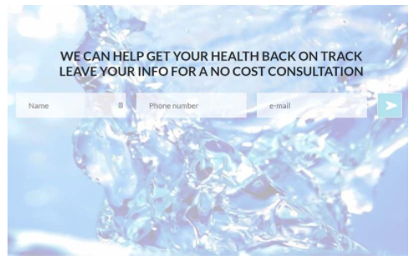

NHP Dental

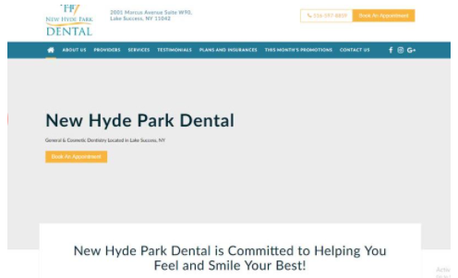

Nyflood Specialist



Tenlee Media Website Development

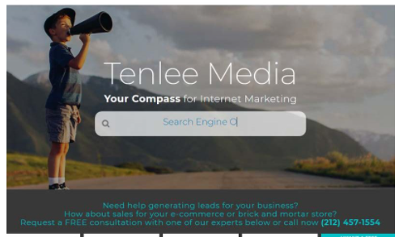

5boroughpropertypros Landing Page Development

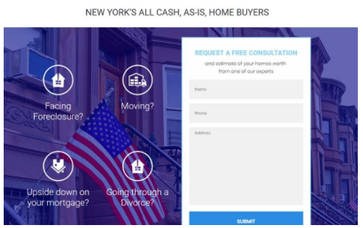

# Chapter 2

# Literature Review

## 2.0 Literature Review

Literature review is a text written by someone to consider the critical points of current knowledge including substantive findings as well as theoretical and methodological contributions to a particular topic. Main goals are to situate the current study within the body of literature and to provide context for the particular reader. In the recent years, the advances in mobile technology have brought an exorbitant change in daily lifestyle of individuals. Smartphones/mobile devices are rampant in all aspects of human life. This has led to an extreme demand for developing software that runs on mobile devices.

## 2.1 Undergraduate Courses related to the Project

In Independent University, Bangladesh, the department of Computer Science organized the courses and syllabus in a very efficient way which helped me a lot to accomplish my project. From CSC101 to 400 level courses, all are very helpful for me. Specially Software Marketing and System Analysis helped me a lot. Database management system, Web application, Software Engineering, C++, Java, data Structure all of these courses helped me to documented and implemented my task in internship program. In my project I have implemented what I have learned in these respective courses. Specially System Analysis and Software Marketing helped me a lot to have a better understanding in this internship program.

## 2.2 Internship Experience & Observation Details

As a student of Computer Science (CSC) everyone has to conduct a practical orientation in any organization for fulfilling the requirements of the 12 weeks Internship Program. The main purpose of the program is to expose the students to the real-world situation. Practical knowledge is fundamental for the application of theoretical intelligence. Bearing this in mind and internship program was being included in the CSC curriculum. The goal of this analysis is to expose the student in the organizational work situation and also to provide an opportunity for applying classroom learning in practice.

I have started working at MediaE360 on 1st March 2021 as an intern in Google Ads, SEO and Software developer Team. For the internship period of 12 weeks, Shameem Ahmed, CEO, MediaE360 was my supervisor. I found very friendly environment there from the first day of my working. Each of the person of the company was so nice and cooperative to me. My supervisor, owner of the company was also very cooperative and friendly whenever I faced any kind of problems in doing the works assigned to me, he always helped me to get out of the problem. I have learned a lot of things there. The most important thing I have observed there is that working is mandatory but beside this we have to be very friendly with others and have to communicate with the people beside our time of working. I have learned also how to cope up with the culture and working environment. Another thing is I have learned that in working life we need to do a lot of work and have to work with lot of data but one thing we need to remember that in every kind of pressure situation, we have to be handled this situation efficiently with patience. Punctuality is very important in working life. Though I have maintained punctuality very efficiently. I used to go there in between 2:00 AM and leaved at 10:00 PM. I have also tried my level best to do the assigned works without any error and tried to deliver the works in the given time.

## Job Responsibilities

During my internship period at MediaE360, I have acquired a new kind of experience. In the very first day I was introduced and I got the basic knowledge about their projects that are going on in the company. Then from next day I started work with Google Ads team directly under the supervision Of Shameem Ahmed, CEO, MediaE360. First 4 weeks I was trained in Google Ads, the training package was a paid course on Google Ads by Isaac Rudansky on Udemy. They provided me some tutorials of search engine optimization. I started watching tutorials and implemented them in their assigned work. Then I was told to research keywords for demo companies inside Bangladesh with the SEO team according to their requirements. After the keyword analysis I was appointed to analyze keywords for client websites who wanted search ads on Google Ads. I have stuck with many errors and problems, but the team was always there to help me with necessary information. Working with firebase was completely a new experience for me. The team was always helpful to me learn new things. Overall these 12 weeks was a fruitful learning journey of my life.

After establishing the targeted keyword phrases and starting position relative to the site’s competitive set, it's important to know what the topic site’s starting position is within the search engines. Doing so ensures that you simply know the precise areas that require work and provides a baseline against which to measure the next campaign’s success.

Access to site traffic information (analytics) is extremely important. These statistics show how searchers are finding and interacting with the topic site, e.g., which search engines, what keyword phrases are getting used , bounce rates, hottest content, etc. Understanding the site’s traffic level and therefore the source of its referrals also can be a critical tool in making other online marketing decisions.

After developing an entire picture of the site’s starting position, goals are set for the SEO plan. These goals are measurable (one big advantage of SEO over other advertising options) and tied to the precise business objectives of the location . within the ongoing progress of reporting and follow up, progress towards the plan’s goals are analyzed and reported. Adjustments to the SEO plan are often made consistent with the findings of those progress reports.

# Chapter 3

# Methodology

## 3.0 Methodology:

The term methodology means the techniques and procedures adopted by conducting a project study. It outlines how the data will be collected, and the tools for collecting data, system methodology, the proposed system input and output, users and system development tools.

In my internship I did not have any specific project to work rather I have worked for a number of domains for their keyword research. I have shown the demo working details of SEO for “NH Park Dental”.

## 3.1 SYSTEM DEVELOPMENT METHODOLOGY (SDLC)

System development methodology is a technique that is used to show how the proposed system will developed. In this case, it is not applicable.

## 3.2 Problem Description

Users use search engines for many of their queries but they only prefer the results available on first page and 2-3% of users continue further pages (except Researchers), Now imagine if the page of a corporation is on 2-3rd or 4th page then the business which may be generated from that page features a very less change to return and user will prefer the page approaching the first page. Trillions of sites are indexed per day during a program .

There are many search per day. Most of the visitor’s visit the web site by hitting the links available in search engines and believe that companies found on the highest results are the simplest brand in their product service and category. These clues make it very clear that if a corporation wants to travel on top within the ir sales then they ought to concentrate in getting their page widely available in the search engines. Then SEO may be a must. For instance , if someone wants to use cab services and is unknown to the place where he's now, normally if he/she may be a techie searches for cab services with the name of city and hit the highest 10 links and use one among these. Getting a really good response in very short span of your time during this particular case is extremely necessary for the customer and to get on top results of an enquiry engine is important for an internet site in order that the customer can easily access it and ultimately let it make profits. I have worked on a lot of the websites during my internship and Im going to show the details of one specific one.

## 3.3 FEASIBILITY ANALYSIS

### Technical Feasibility

Technical Feasibility assesses the present resources and technology, which are required to accomplish the goals within the allocated time and for this, the team ascertains whether the present resources and technology are often upgraded or added to accomplish specified requirements.

Technical feasibility of the merchandise has been studied under following heads:

(a) **Hardware** - This project requires any device with internet connection. (Here we'll be using laptops for testing purpose)

(b) **Platform Independence** –This analysis project was platform independent as its website can beaccessed with the help of internet on any platform.

(c) **User friendly** -The website’s interface was built on wordpress which has rich userinterface tools and for its SEO, Google analytics which is a free service provided by the Google was used and also a paid service by SpyFu was used for analyzing its state, this system was definitely user friendly.

As hardware availability and user friendly nature of this project is possible to achieve, this system is technically feasible.

## 3.3.1 Economic Feasibility

This project requires a website name and web hosting for constructing the web site and further deploying it. My web developing team completed the website and sent me the site’s page for keyword analysis for a better online marketing research.

(i) **Hardware cost** – there's no hardware cost related to this. However, a website name and web hosting is required to host the web site . So it'll result into some minimal charges.

(ii) **Software cost** - Software needed for development of this website are open source software i.e. wordpress. Hence, there's no cost related to them. For the keyword analysis and optimization I have used Google Keyword Analytics and a paid software, SpyFu.

As hardware cost are very low and as software are readily available, this technique is economic feasible.

## 3.3.2 Operational Feasibility

Operational feasibility may be a measure of how well a proposed system solves the issues. We all know without SEO where an internet site will lie and after SEO what proportion its usability will increase. Thus the system is operational feasible.

## 3.3 SYSTEM REQUIREMENTS ANALYSIS

## 3.3.1 Platform specification

This project are going to be platform independent since its website are often accessed with the assistance of internet on any platform. But to deliver high levels of reliability, availability and serviceability the configuration needed is as follows:

**(i) Hardware Specification**: Any device with internet connectivity is required.

**(ii) Software Specification:** The above mentioned device must contain a well updated browser to run the web site and implement the SEO techniques and software.

## 3.3.2 Functional requirements

Project shall have an internet site on dental clinic (NH Dental Park) which appears among the highest searches of an enquiry engine whenever an individual searches something associated with these things:

1. Website shall have only original content from the authenticated users and reviewers.

2. The web site once deployed shall maintain its ranking within the SERP with the assistance of SEO techniques.

3. Website shall have its content as per the Google algorithms in order that web crawlers can display this website on the required searches.

## 3.3.3 Business end requirements

1. Website should recover its ranking just in case of any failure.

2. Website shall have an option of including new techniques so on maintain its ranking.

## 3.3.4 Non-functional requirements

This section specifies the specified system quality factors that aren't associated with the precise functional requirements. These requirements are always required to be fulfilled.

**(i)Safety and Security:** The admin will keep a check on the first content being posted by the reviewers and also has got to make sure that this doesn't get copied. There will a way to evolve to the copywriting problems with the content.

**(ii)Performance**: This subsection checks the very fact that our interface must perform during a way user expects. It is also related to the speed with which the system shall function.

**(iii)Reliability**: The audience must believe the matter displayed on the location because the content won’t be plagiarized and can the reviewer believe the web site so as to not disclose their identity on the other platform without the consent.

**(iv)Reusability:** Since the content posted on the web site is original in nature; whenever anybody visits the location would get the thought about the actual experience. Hence the content never gets outdated. Also just in case of any changes to the very fact mentioned within the post the admin will confirm to possess as little a difference within the description and reality as possible.

## 3.3.4.1 Using SpyFU

SpyFu, a paid SEO keyword analysis tool for selecting the right keywords according to their price and search volume for NH Park Dental.

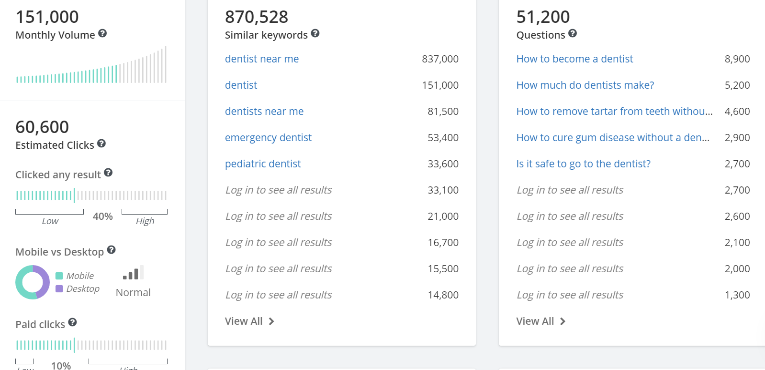

#### Fig 1: Monthly volume and estimated click analysis of the keyword “dentist” on SpyFu

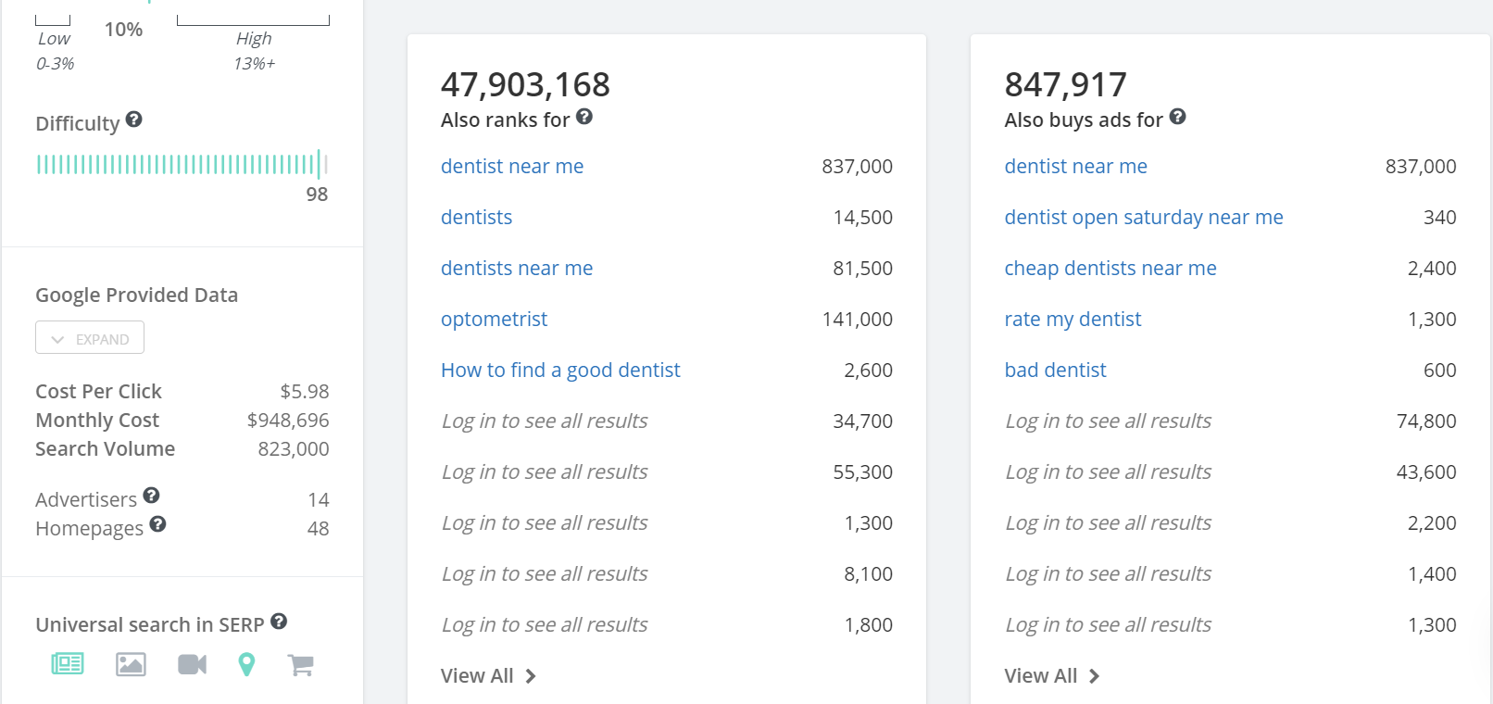

#### Fig 2: Monthly cost, cost per click (CPC) and search volume results by Google

I have used SpyFu also mainly for seeing other similar competitors of our client, I checked on the impression rates of others on Google As and followed the best sites for a better competition on the search ads of Google Ads.

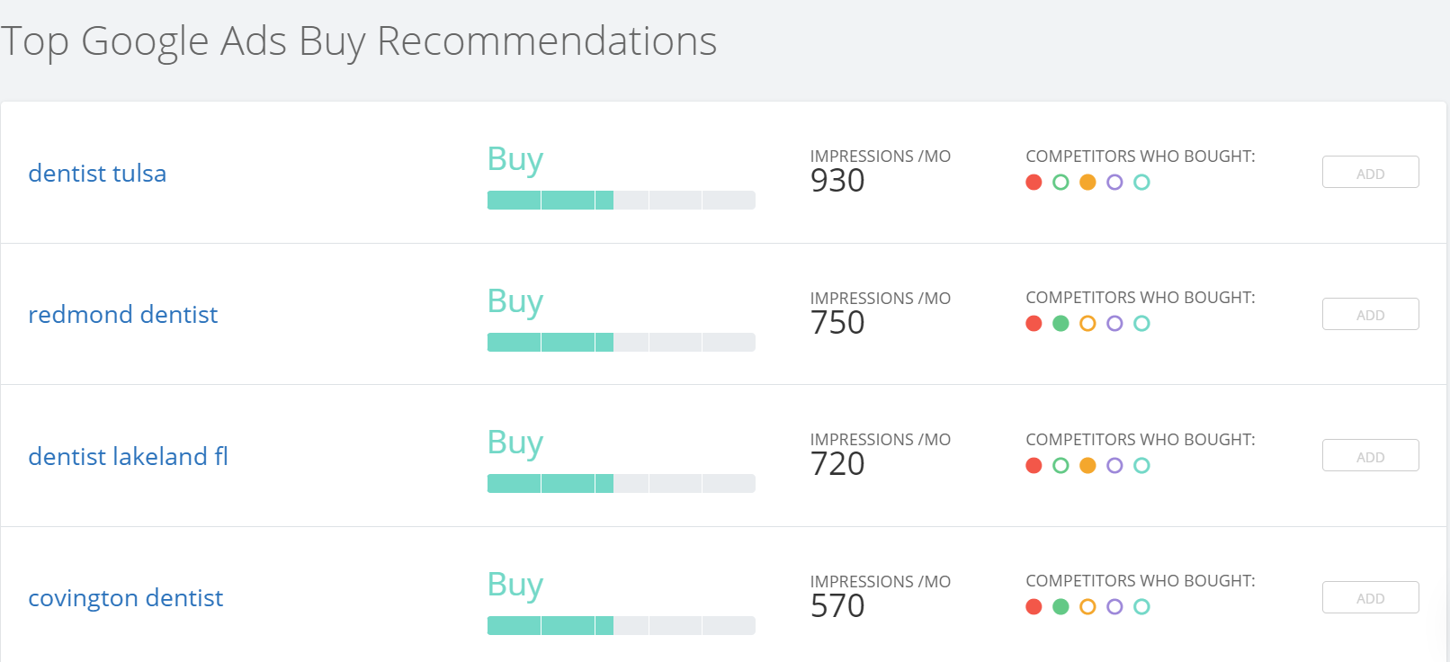

#### Fig 3: Top Google Ads impressions/month data for different competitor’s analysis.

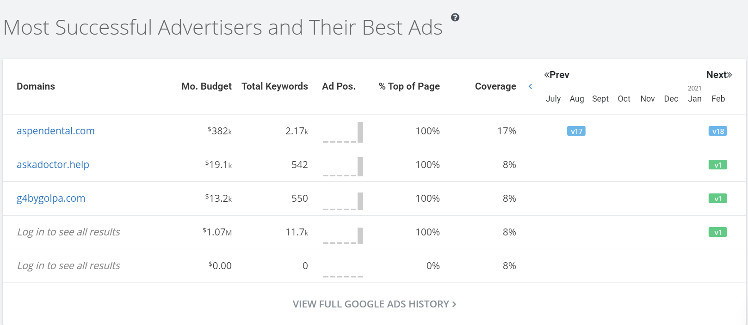

#### Fig 4: Successful related advertisers, their monthly budget and coverage percentage.

SpyFu also gave me organic ad results and detailed cost overview with the number of clicks, impression, backlinks and other related information needed.

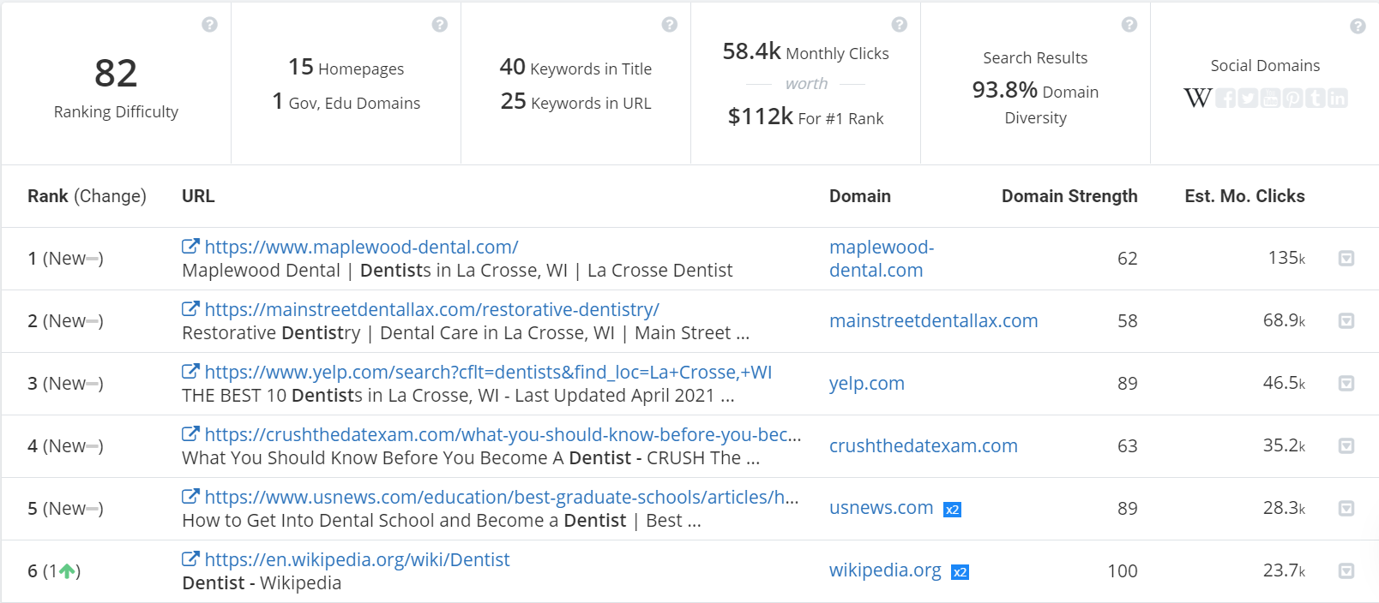

#### Fig 5: Analysis of the top ranked websites, their estimated monthly clicks and domain strength

Also shows the top ranked ads for each keyword.

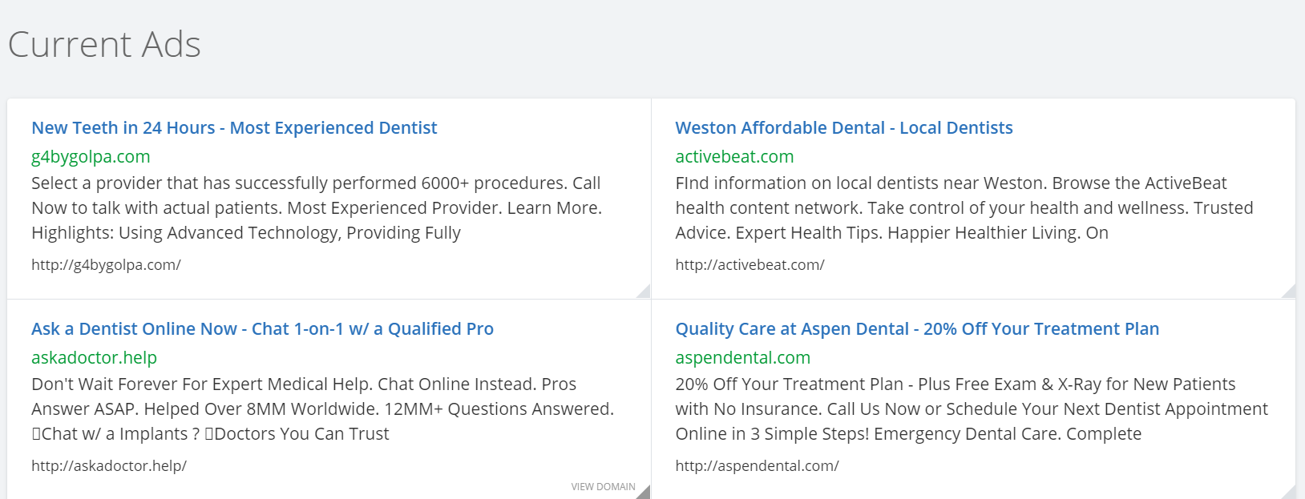

#### Fig 6: Currently shown ads related to the same keyword on search result pages.

After the required information gathered for the specific keyword (dentist), I go back and repeat the same analysis for another different keyword (dental) used in our clients website.

Then used the long tail keyword (dentist near me) for the same process. And many more other keywords aswell.

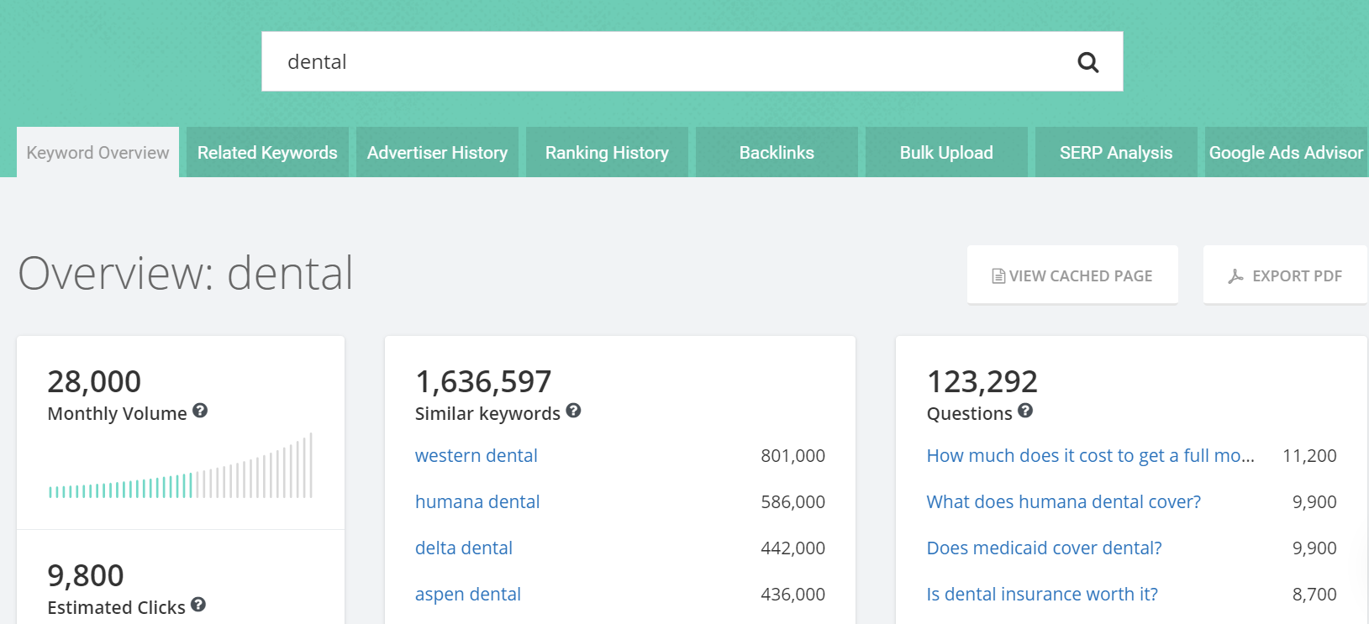

#### Fig 7: Repeating the same analysis for a different keyword, “dental”.

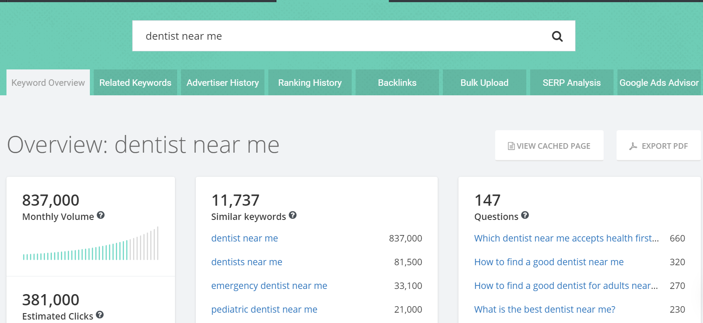

#### Fig 8: Another overview of the keyword “dentist near me” with the same analysis

As I had to work on teamviewer, an online remote controlling pc software with my company’s email address, I was unable to take screenshots of them, restricted in teamviewer software and also my company’s policy of keeping the information of clients confidential. So I have used a demo analysis on SpyFu for showing the analysis overview for a lot of keywords in repeat.

# Chapter 4

# Result and Test Analysis

## 4.1 Testing

Testing is the process of verifying and validating the system for the conformance with specification and meeting the customer’s requirements. The objectives of testing are to ensure that the system programs are error free, guarantee the system end users can interact with the system well and ensure that the components of the system interface are working well

## 4.1.1 Functional Testing

The purpose of functional testing is to ensure that the program performs all the functions that were originally specified, that all the input is correctly accepted. It relates to the whole system and does not require a technical understanding of the system. All the functions of the system as originally specified are systematically tested to ensure that nothing has been accidentally omitted or misinterpreted. A positive attempt is made to anticipate errors than an inexperienced user might make, and tests made to check the effect of such errors and ensure that they do not result in incorrect actions or bad search results for specific keyword by user.

## 4.1.2 System Testing

This is where the system is checked whether it has met the user requirements and performs as per expectations. The following are the tests to be used. On completion of the whole process of keyword analysis and SEO, each of it is tested to ensure no errors have been introduced.

## 4.2 Test Data

The purpose of test data is to verify and make sure that the website is operating well and according to the standards set. It involves checking the new system if it is working correctly. We have tested it by applying random keywords on search list and also keywords related to our client’s website to check the search ad results.

## 4.2.1 Test Results

After completing test process, the search ads result came accordingly with less competitive ranks for unrelated keywords and highly competitive for keywords related to NH Dental Park.

I have generated two keyword analysis report from SpyFu for NH Park Dental, the report was further used for applying those analyzed keywords in Google Ads for a search ad of the client.

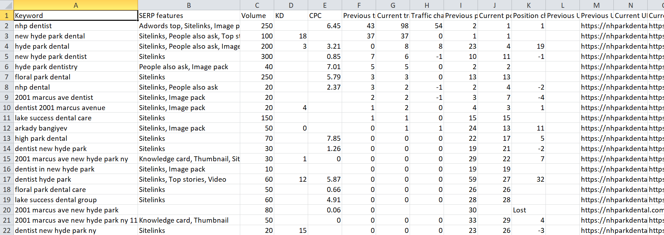 Fig 9: Keyword research along with volume, CPC, traffic rates, etc. for NH Park Dental.

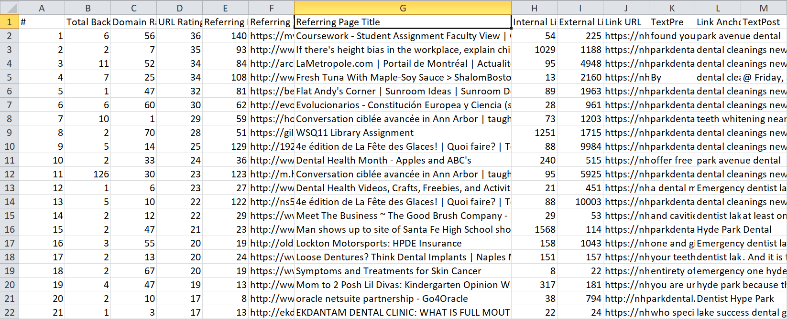

#### Fig 10: Total backlinks, URL rating, Domain rating and referring page titles for our client, NH PARK DENTAL

# Chapter 5

# Internship Outcome & Issue Analysis

## 5.2 Issue Analysis

Search engine advertising is one of the most popular forms of PPC. It allows advertisers to bid for ad placement in a search engine's sponsored links when someone searches on a keyword that is related to their business offering. For example, if we bid on the keyword “PPC software,” our ad might show up in the very top spot on the Google results page Every time our ad is clicked, sending a visitor to our website, we have to pay the search engine a small fee. When PPC is working correctly, the fee is trivial, because the visit is worth more than what you pay for it. In other words, if we pay $3 for a click, but the click results in a $300 sale, then we’ve made a hefty profit.

A lot goes into building a winning PPC campaign: from researching and selecting the right keywords, to organizing those keywords into well-organized campaigns and ad groups, to setting up PPC landing pages that are optimized for conversions. Search engines reward advertisers who can create relevant, intelligently targeted pay-per-click campaigns by charging them less for ad clicks. If your ads and landing pages are useful and satisfying to users, Google charges you less per click, leading to higher profits for your business.

Thus the best way to fit in you profit is via a better platform for digital marketing, in this case Google Ads is the best choice.

## 5.2.1 Problems & challenges faced in the workplace

The different challenges faced by the author during the course of Internship at MediaE360 included the following:

**A New Routine**

I had to adjust to the new routine and new lifestyle. For, the first couple of days, I found it extremely difficult being surrounded by strange people and sitting in front of a laptop for six to eight hours straight.

Also, the unofficial lockdown didn’t help. I had to walk a lot every week for reaching office at 2:00 pm due to shortage of vehicle.

**Identity**

In the beginning, position wasn’t clear to most of the employees in the host company. On multiple occasions, author was mistaken for a virtual assistant/content writer.

**Not Enough Work**

The main reason I joined the Internship was to gain valuable work experience but at times author felt extremely dejected and frustrated with lack of relevant work opportunities, opportunities that added value to both the company and the author.

**Not Enough Direction**

Occasionally, I was presented with unclear assignments to which I had absolutely no clue. My reluctance to ask questions made the matter worse.

**Not Enough Feedback**

I lacked timely feedback from the supervisor and other staffs of the host company. Author believes weekly meetings with the supervisor would have helped foster the overall growth.

## 5.2.2 Recommendation

Here is some recommendation for company:

* They should maintain standard quality of products and services.
* They should maintain collecting continuous feedback from client side.
* Though they work with so many projects and which are more than enough for this company. Still my recommendation will be more focused on promotional activities.
* For fresh ideas and new perspective, they need to recruit more youth and fresher because youth are the source of new ideas and new innovation.
* Since MediaE360 work for many systems for their operation and clients, so they need watchful maintenance of the systems by the responsible management.

# Chapter 6

# Conclusion & Implication

## Conclusion and implication

During my internship I worked on Google Ads platform for creating quality ads generated by top notch keywords from researching thoroughly via search engine optimization. During the internship period I have been trained on various optimization skills for a better social media advertisement.

It has been a great opportunity for me to work as a Google Ads Assistant during my internship at MediaE360. This three-month internship program was like a step stone to my carrier within the work advertise. During the internship I learned numerous vital information on search engine optimization and marketing on social media platforms and also on Google for search ads. The internship program made a difference me to pick up vital information almost how the marketing segment forming in our nation. Internship at MediaE360 instructed me how to handle distinctive client, later program related advances, regularly utilized advances and best utilized of this innovation. This program gave me a clear thought around proficient life as a digital marketer, keyword researcher and SEO. During internship, during this study, I know much more about digital marketing development. How it works? The properties, objects and others. This internship gives me a chance of developing communication skills, growing creative thinking and imagination capability.

# 7.0 Reference

* [**https://dandelionmarketing.com/website-design/local-seo-packages/seo-process/**](https://dandelionmarketing.com/website-design/local-seo-packages/seo-process/)
* [**https://blog.hubspot.com/marketing/seo-strategy**](https://blog.hubspot.com/marketing/seo-strategy)
* [**https://www.researchgate.net/publication/318659361_Survey_on_Search_Engine_Optimization_Tools_Techniques**](https://www.researchgate.net/publication/318659361_Survey_on_Search_Engine_Optimization_Tools_Techniques)
* [**https://www.ncbi.nlm.nih.gov/pmc/articles/PMC6055554/**](https://www.ncbi.nlm.nih.gov/pmc/articles/PMC6055554/)
* [**https://journals.sagepub.com/doi/abs/10.1177/2278682117754016**](https://journals.sagepub.com/doi/abs/10.1177/2278682117754016)
* [**https://authorservices.taylorandfrancis.com/research-impact/search-engine-optimization-for-academic-articles/**](https://authorservices.taylorandfrancis.com/research-impact/search-engine-optimization-for-academic-articles/)

# 8.0 Appendix

**Weekly Tasks**

|  |  |  |
| --- | --- | --- |
| **Week** | **Date** | **Work** |
| 1 | 1/3/2021 | Introduction to the official environment and introduction to training on Google Ads platform. |
| 2 | 8/3/2021 | Getting idea about how to improvise PPC marketing for Google ads platform. |
| 3 | 15/3/2021 | Getting familiar with factors that can be changed to have a better conversion rate. |
| 4 | 22/3/2021 | Setting up my first demo Google ads account and implementing target location, bidding strategies and other extensions for business inside Bangladesh |
| 5 | 29/3/2021 | Learn to use callout, call, structured snippet, app, location, promotion and price extensions on Google ads. |
| 6 | 5/4/2021 | Started learning and using basic keyword research and basics of search engine optimization (SEO) |
| 7 | 12/4/2021 | Using SEO analytic tools to check CPC and keyword bidding price for real clients. |
| 8 | 19/4/2021 | Analyzing website traffic, domain ranks, internal links, external links and total number of linked domains for "NH PARK DENTAL" |
| 9 | 26/4/2021 | Enter the implementation phase: Start using best priced keywords for company's website search ads on Google ads. |
| 10 | 3/5/2021 | Using SpyFu, an SEO tool to collect different domains that generates the most leads. |
| 11 | 10/5/2021 | Targeting client domains for keyword optimization of search ads. |
| 12 | 17/5/2021 | Analyzing previously fetched keyword datasets of client domain. |